**HTML Contents**

|  |
| --- |
| **HTML Main page**   * Input box for Login Credentials * Login & Redirect * User Registration Redirect |

|  |
| --- |
| **User Registration HTML Page**   * User Name * Upload set of images * Image selection from gallery for password * Set Pattern Sequence as password * Confirm Pattern Sequence * Submit & Pop User Registration status |

**Create Image Point Mark & set pixel tolerance**

|  |
| --- |
| **Backend execution**   * Store the credentials in Database |

**Software Requirements**

* Django
* Sqlite
* Python
* Visual Studio Code
* Angular Cli

**Flowchart for Graphical Password Authentication**

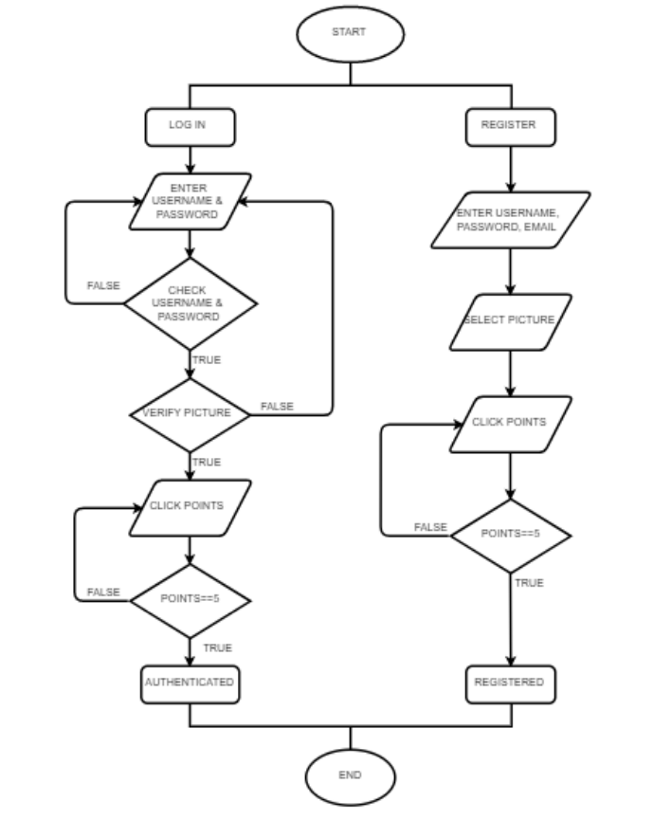

**For new User**

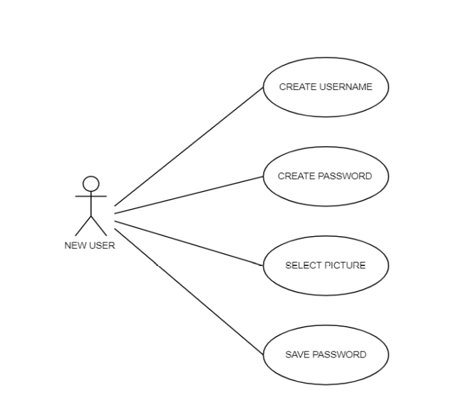

**For Existing User**

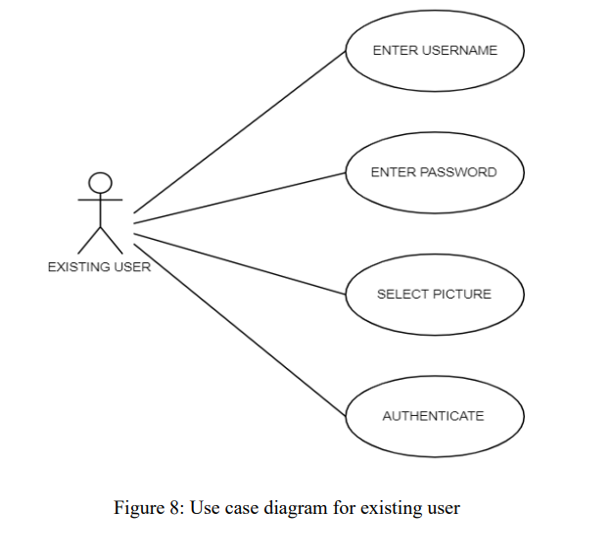

**Sequence for Registration Process**

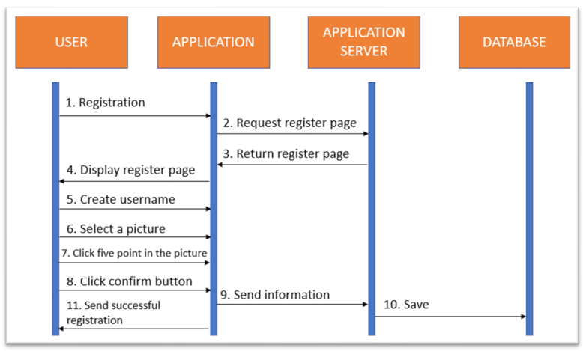

**Sequence diagram for log in phase**

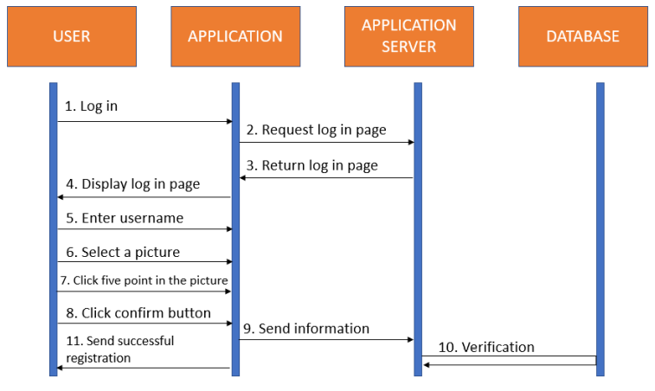

**Module Split-Up**

1. **Image Submission** through HTML & store in database & update the selection – **Manisha**
2. **Image Password Point Mark**- Split up the pattern clicks & Store the sequence in database – **Prudhvi**
3. **Pixel Tolerance-** Calculation for the selected clicks – **Pravalika**
4. **Authentication**- Match the clicked sequences by the user from the database and Authenticate - **Harsha**